# **How to Edit the Resources Page Content**

1. Log in to your WordPress admin dashboard. In the left sidebar menu, click on "Pages – All Pages".

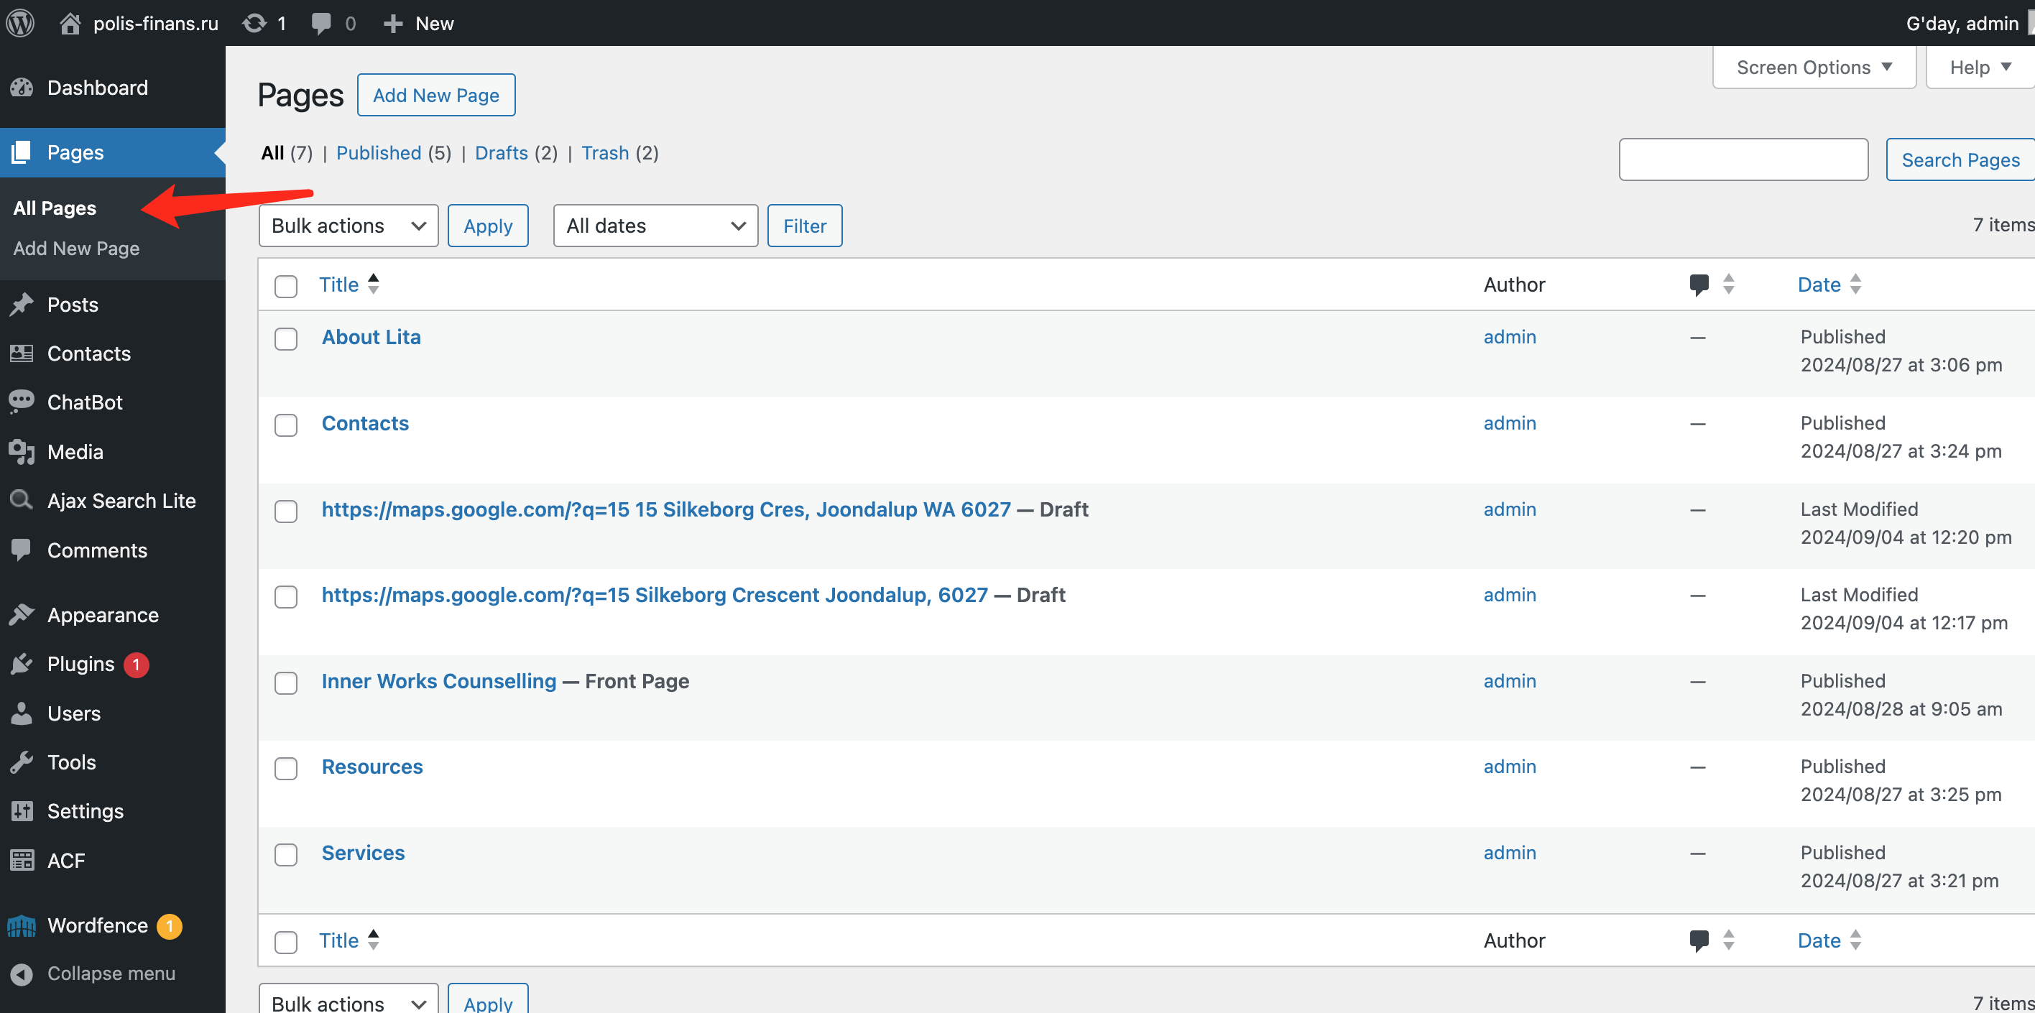

1. On the Pages screen, locate the "Resources" page in the list of pages. Hover your mouse over the "Resources" page title and click "Edit" when it appears.

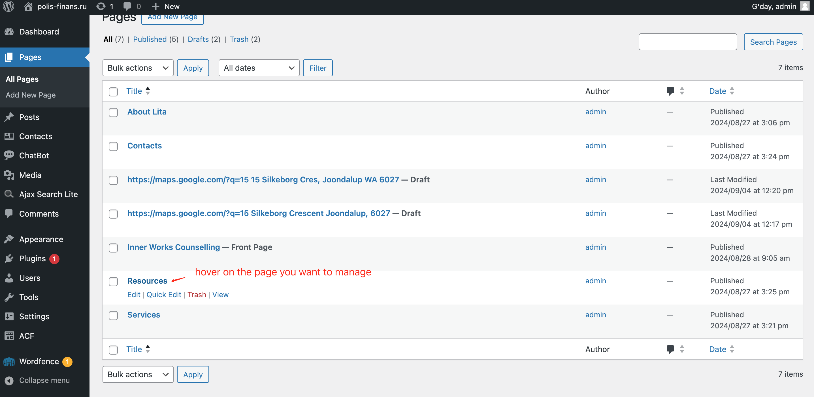

1. You'll be taken to the page editor.

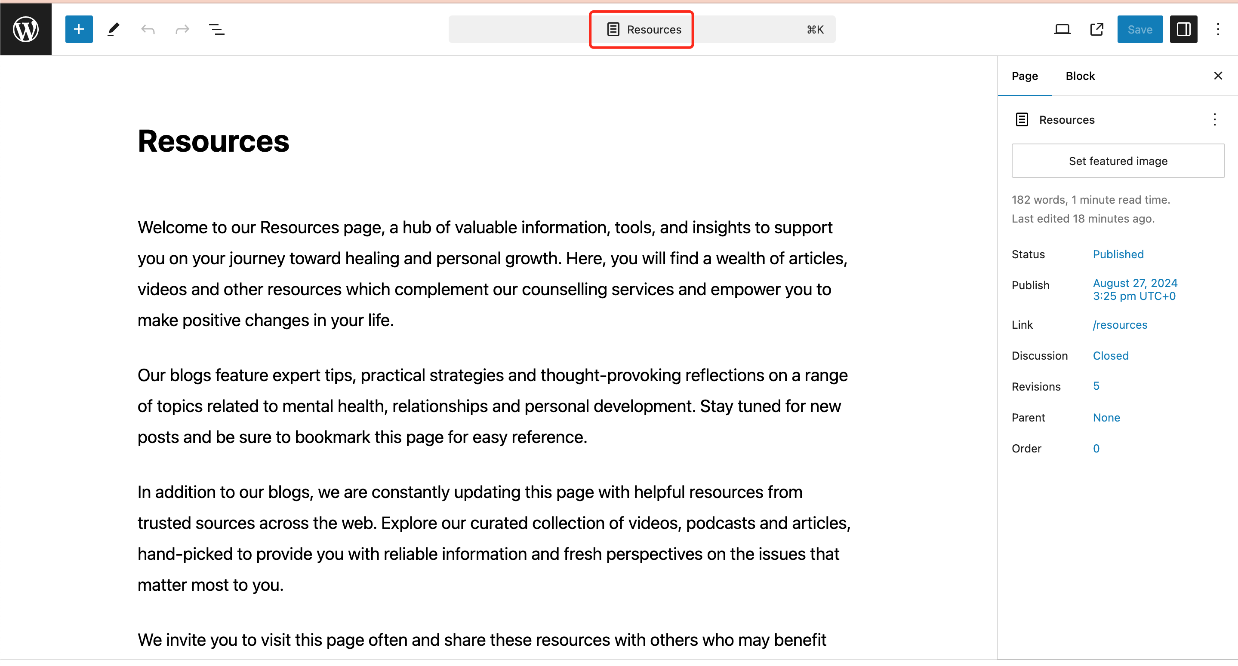

1. To change the title:

* Click on the "Resource" text at the top of the page.
* Type your new title to replace "Resources".

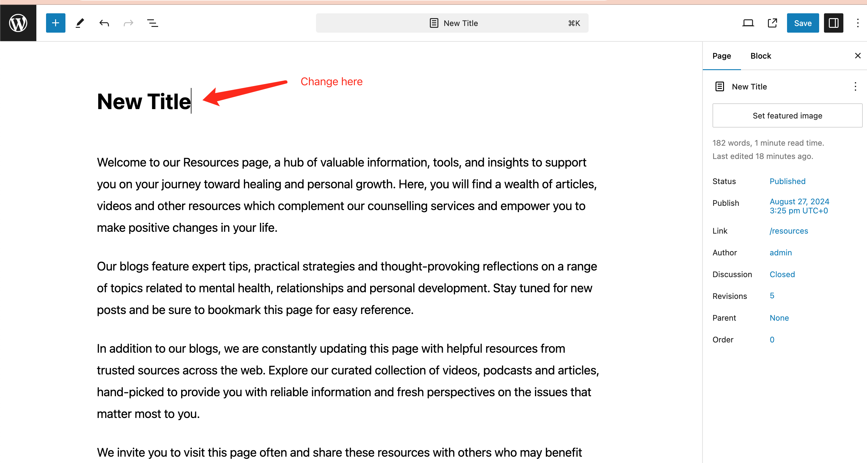

1. To edit the content:

* Click on the paragraph you want to modify.
* Use the text editing toolbar that appears above the paragraph to format your text (bold, italic, link, etc.)
* Type or paste your new content directly into the paragraph block.

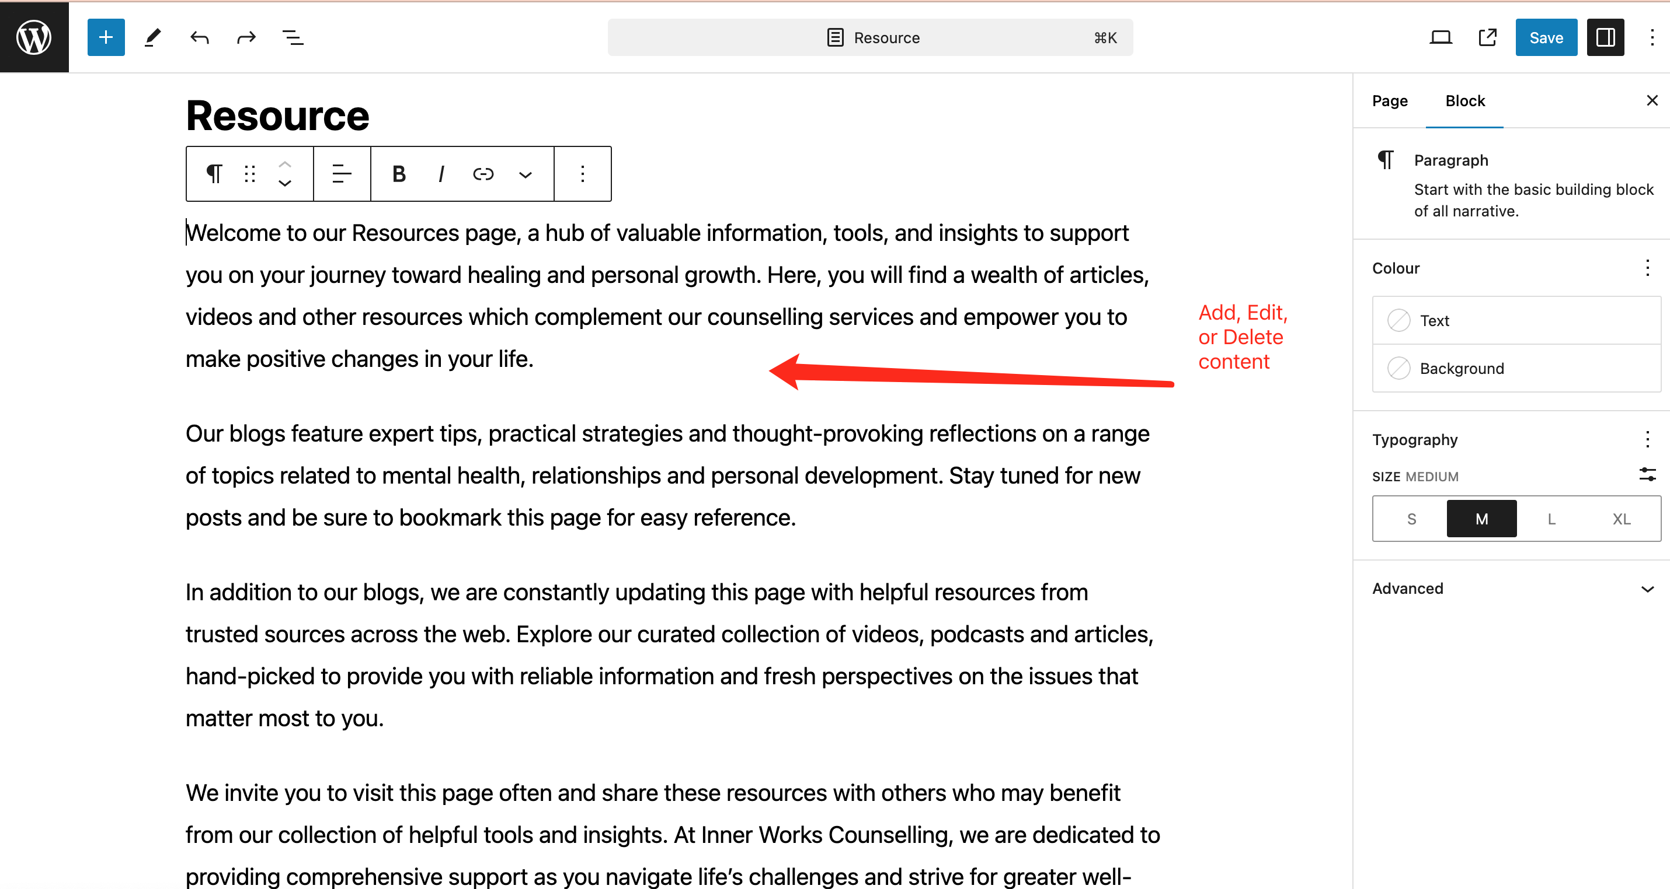

1. To add new content:

* Click the "+" icon at the top left of the editor to add new blocks (like paragraphs, headings, images, etc.)



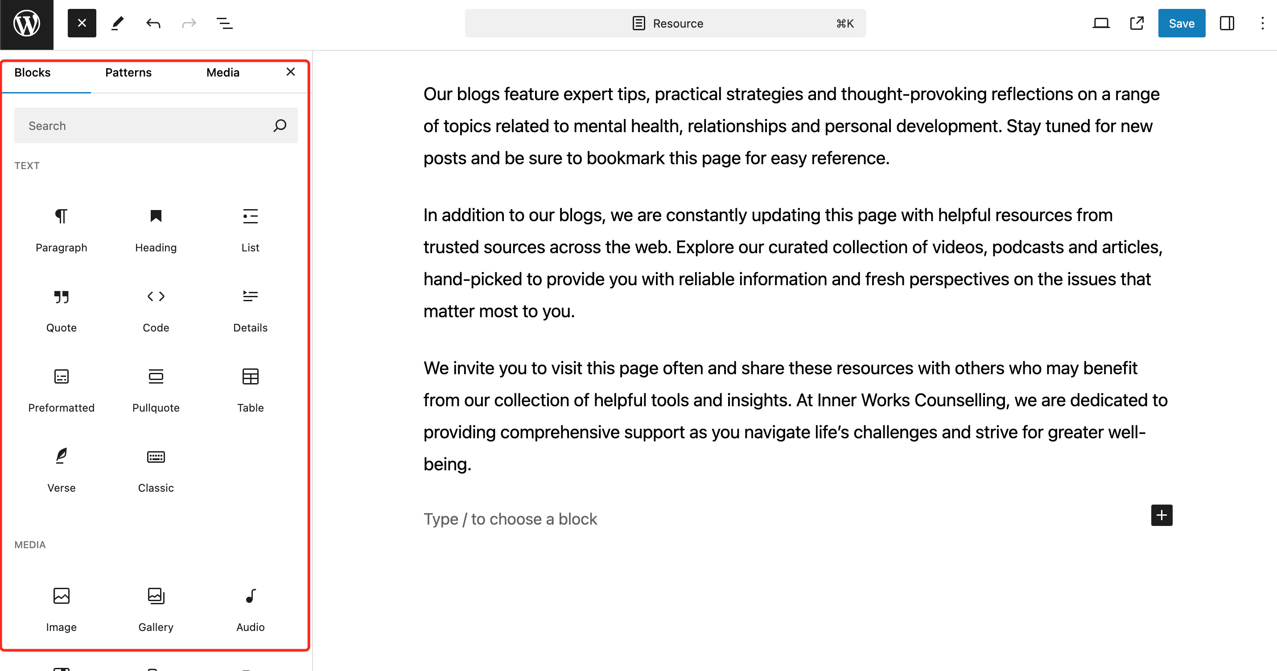

1. To preview your changes, click the laptop icon in the top right corner. This opens a dropdown menu with several options:

* Desktop: Preview how the page looks on desktop screens.
* Tablet: Preview the page layout for tablet devices.
* Mobile: See how the page appears on mobile phones.
* Preview in new tab: Opens a full preview of the page in a new browser tab.

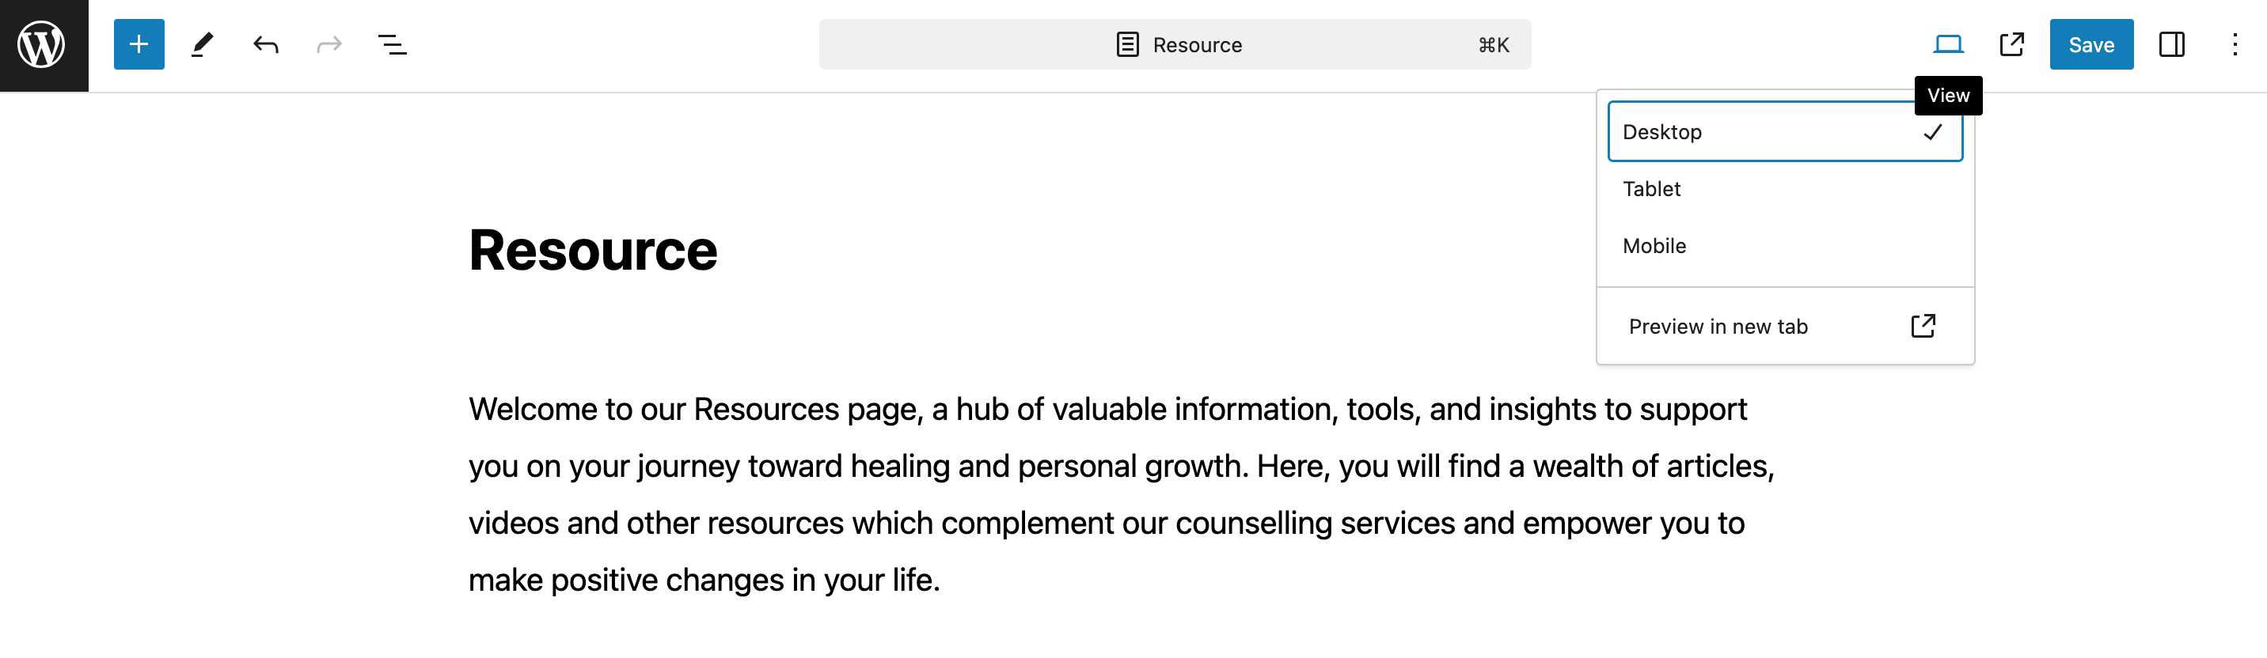

1. After previewing, click the "Save" button to publish your updates. Visit your website to verify the changes appear as intended.

